The Fonts:

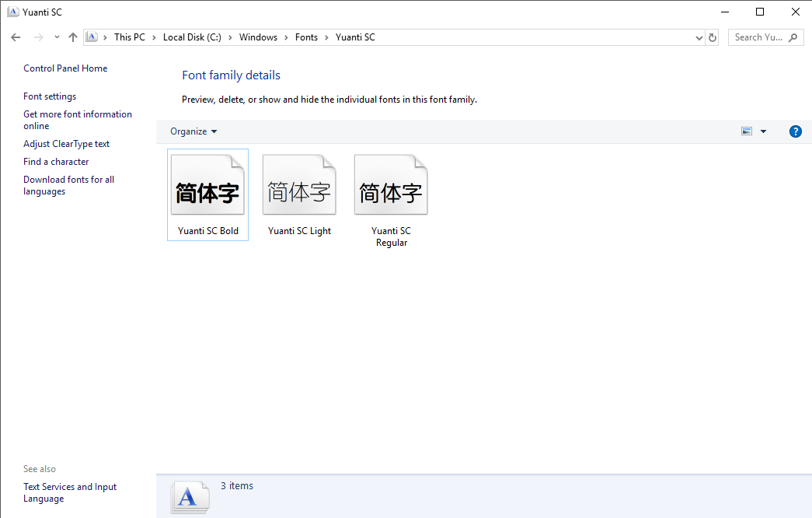
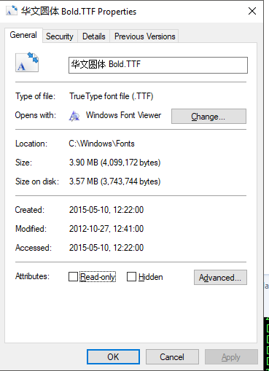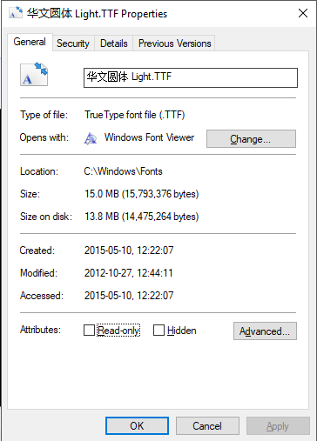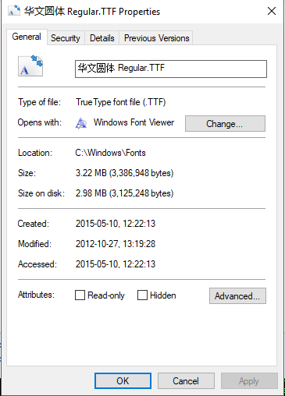

The code:
The original code is like this:
foreach (var family in FontFamily.Families)
{
_existingFontFamilies.Add(family.Name, family);
}

I changed to this form to fix this bug and ease the debug:
foreach (var family in FontFamily.Families)
{
if (_existingFontFamilies.ContainsKey(family.Name))
{
Console.WriteLine("Font already exist"); // add breakpoint here
}
else
{
_existingFontFamilies.Add(family.Name, family);
}
}

The problem:

When hit the break point, here are these variables’ status:
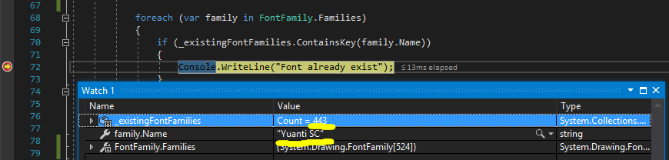

And this is the content of FontFamily.Families:

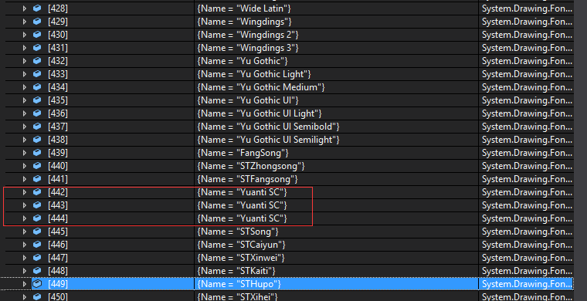

The Solution:
I test and check the code of later version (1.5.0) of HtmlRenderer, which doesn’t have this bug. It changed to indexer access, instead of Add() method:

/// <summary>
/// Adds a font family to be used.
/// </summary>
/// <param name="fontFamily">The font family to add.</param>
public void AddFontFamily(RFontFamily fontFamily)
{
ArgChecker.AssertArgNotNull(fontFamily, "family");

_existingFontFamilies[fontFamily.Name] = fontFamily;
}

Checkout at following github file:
https://github.com/ArthurHub/HTML-Renderer/blob/master/Source/HtmlRenderer/Core/Handlers/FontsHandler.cs

Line 84 to 89.

So we can fix this in the same way, or upgrade to the later version.

