Bug #92822
Proceedure
- Create a Test Schema.
Start MYSQL Workbench, logon as root and create a schema
CREATE SCHEMA `test` DEFAULT CHARACTER SET utf8 COLLATE utf8_unicode_ci ;
- Open a SQL Window and create a test table and stored procedure.

SQL To Generate Test Table & Procedure
USE TEST;
DROP TABLE IF EXISTS `TESTPROC`;
CREATE TABLE `TESTPROC` (
`KEY_ID` BIGINT(10) NOT NULL AUTO_INCREMENT,
`FIELD1` VARCHAR(30),
`FIELD2` VARCHAR(30),
`FIELD3` BIGINT(10),
`FIELD4` BIGINT(10),
`FIELD5` VARCHAR(30),
`FIELD6` VARCHAR(30),
PRIMARY KEY (`KEY_ID`)
) ENGINE = INNODB;

DROP PROCEDURE IF EXISTS PI_TESTPROC ;
DELIMITER $$
CREATE PROCEDURE PI_TESTPROC (
OUT PKEY_ID BIGINT(10),
IN PFIELD1 VARCHAR(30),
IN PFIELD2 VARCHAR(30),
IN PFIELD3 BIGINT(10),
IN PFIELD4 BIGINT(10),
IN PFIELD5 VARCHAR(30),
IN PFIELD6 VARCHAR(30)
)
BEGIN
INSERT INTO TESTPROC(
FIELD1,
FIELD2,
FIELD3,
FIELD4,
FIELD5,
FIELD6)
VALUES (
PFIELD1,
PFIELD2,
PFIELD3,
PFIELD4,
PFIELD5,
PFIELD6);

SET PKEY_ID = LAST_INSERT_ID();
END$$

DELIMITER ;

The Workbench window should appear similar to the following.
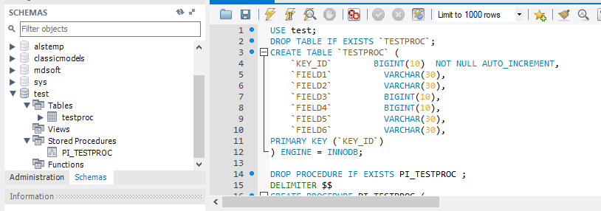
- Use Workbench to execute the Stored Procedure

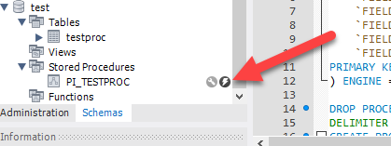
- Enter the values as shown below.
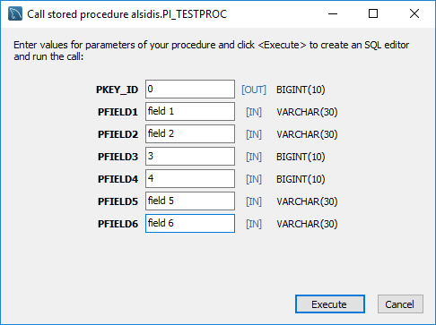

- Press Execute MySQL Workbench displays the following.
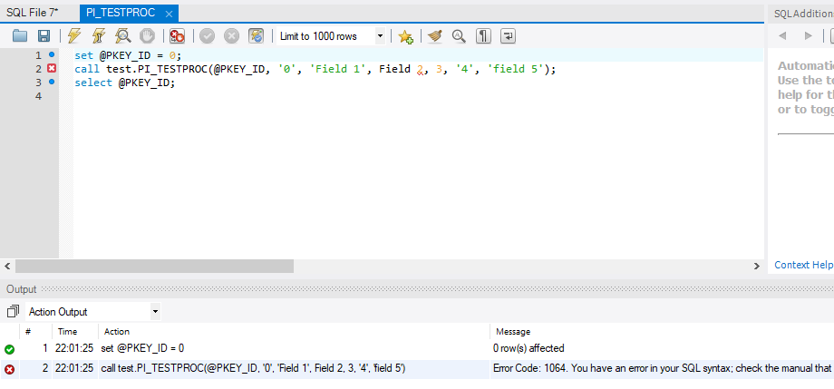
following SQL is generated was generated.
set @PKEY_ID = 0;
call alsidis.PI_TESTPROC(@PKEY_ID, '0', 'field 1', field 2, 3, '4', 'field 5');
select @PKEY_ID;

Issues
1. 0 should not be present.
2. the values field 1 and field 2 should be quoted, field 2 is not quoted
3. The values 3 & 4 should not be quoted, 4 is quoted.
4. The entry for field 6 is missing.

Correcting the SQL manually and running returns the insert of the last key field.
set @PKEY_ID = 0;
call alsidis.PI_TESTPROC(@PKEY_ID, 'field 1', 'field 2', 3, 4, 'field 5', 'field 6');
select @PKEY_ID;

