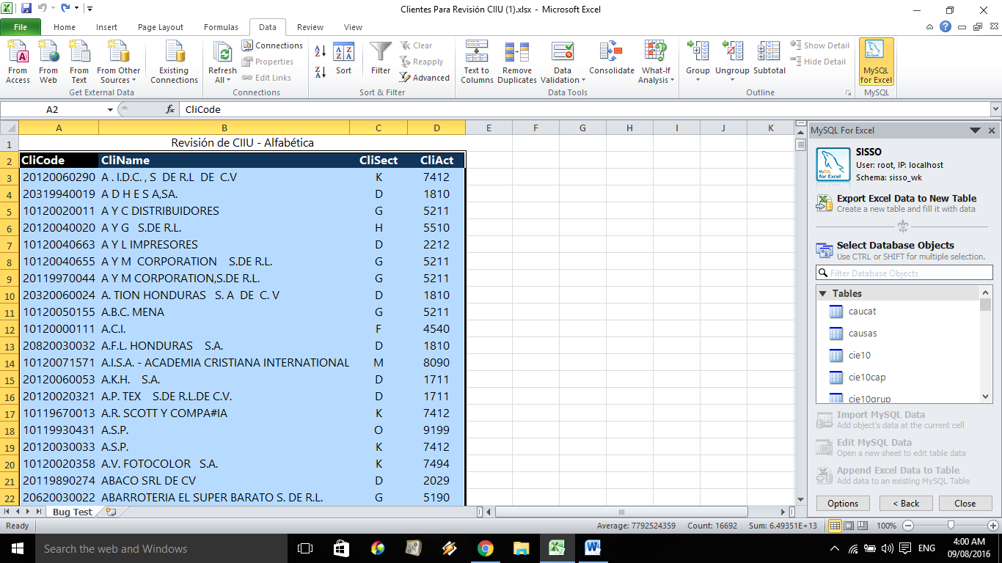
Choose ”Export Excel Data to New Table”.
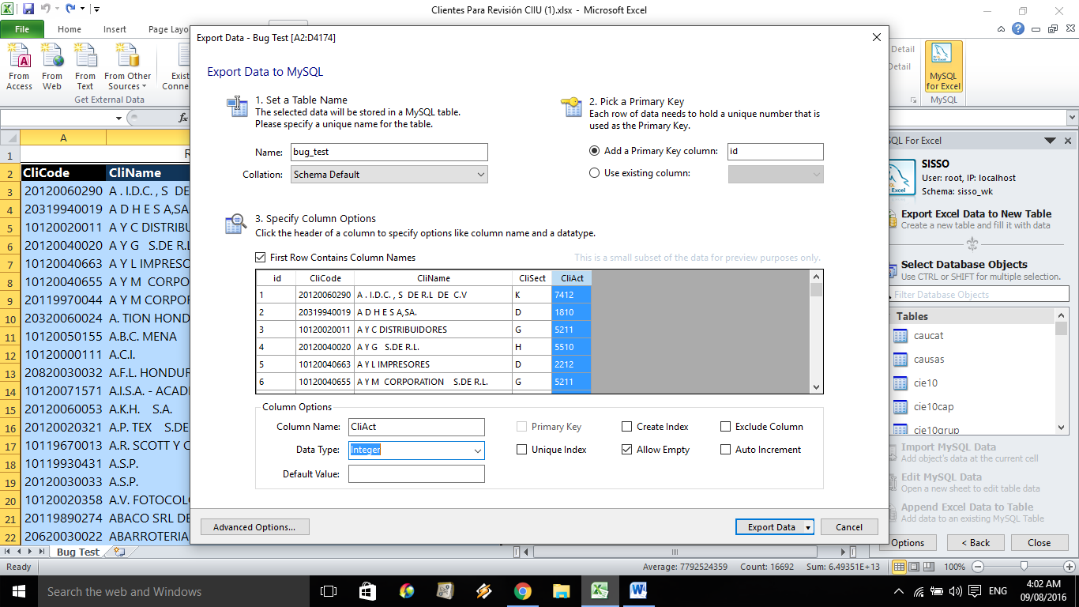
Last field “CliAct” change to integer.
n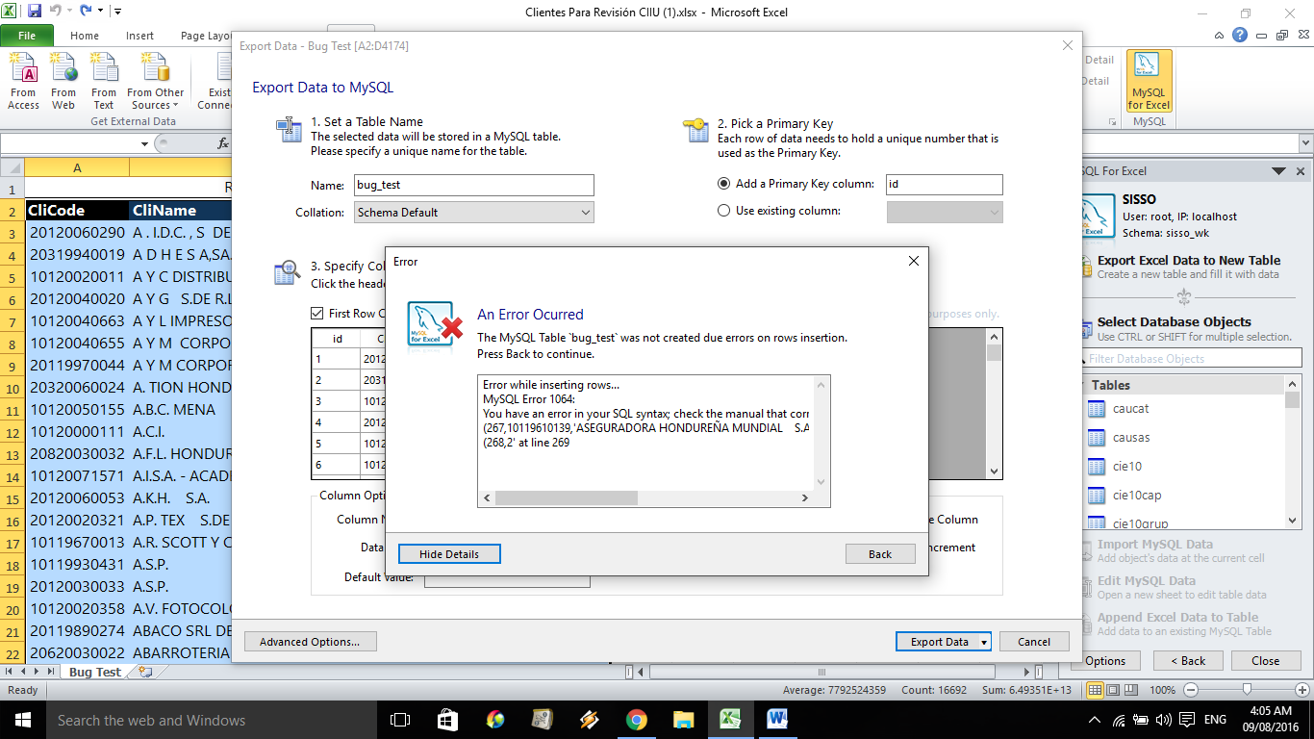
Lookup row 269 (267+2 headers) in the Excel table. Notice that it follows row 268 which has two null fields in columns C (CliSect) and D (CliAct).
Eliminate row 268 with the null fields from the table. Run again…

