This is the CPU graph of node 3 during the restart phases, starting this afternoon.
The Thraed configuration:
cpu 1,2,6,7 Local Data Manager
cpu 8 Main
cpu 8 IO
cpu 9 Replicator
cpu 10 Transaction Coordinator
cpu 11 Receiver

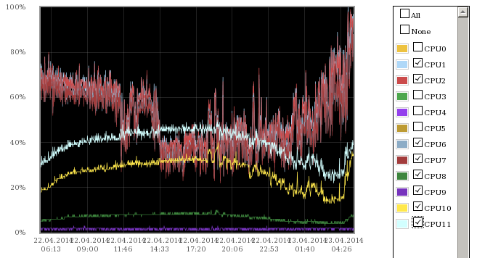

This is the same graph durig normal condition:… just the 24 hours before…


