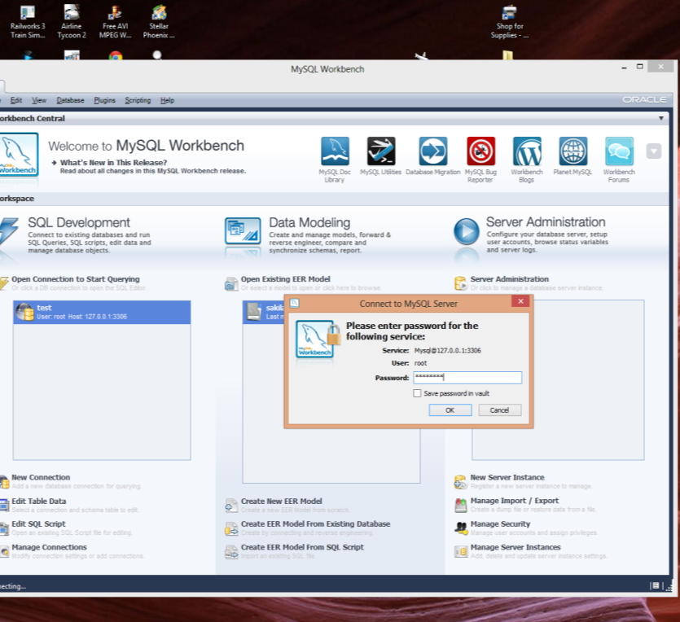
BEFORE

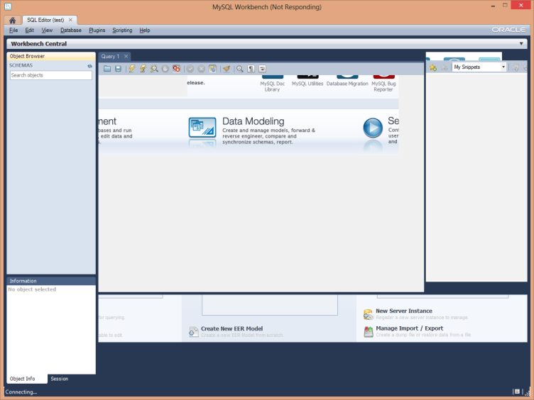
AFTER

It looks like it start to connect, but can’t (yet test connection works)…

