Two of the tables in the edmx file produced from the MySql database
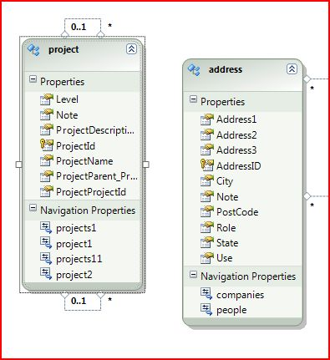
The associations with the address table are many to many
Note that the Entity sets were not correct in the properties. They were not pleuralized version of the table names.

The same tables in the original edmx file from Sql Server
(associations on the Address table are many to many)


